CMSC 433 Scripting Languages

Project 2 “Oregon Trail” Documentation

May 16, 2017

**The Team:**

* Michael Kelbaugh – [kelbaum1@umbc.edu](mailto:kelbaum1@umbc.edu)
  + design and implementation leader
  + lead developer
  + database manager
* John Larson – [larson3@umbc.edu](mailto:larson3@umbc.edu)
  + graphics and animation developer
* Christopher Blake – [cblake2@umbc.edu](mailto:cblake2@umbc.edu)
  + general developer
* Mansi Shah – [mansha1@umbc.edu](mailto:mansha1@umbc.edu)
  + CSS developer

**Project Location:**

To play the game, go to:

<https://swe.umbc.edu/~kelbaum1/Oregon/proj2.html>

To watch the demo video, go to:

<https://www.youtube.com/watch?v=blrFrpGehh4>

The complete source code and graphics are located on GitHub:

<https://github.com/kelbaum1/Oregon-Trail/tree/master/final>

The complete source code and graphics are also in proj2.zip, located on UMBC's GL:

/afs/umbc.edu/users/s/l/slupoli/pub/cs433/Project2/kelbaum1

**Project Description:**

The project is a web-based implementation of the classic "Oregon Trail" computer game.

<https://en.wikipedia.org/wiki/The_Oregon_Trail_(video_game)>

The project has been tested in the Google Chrome web browser (version 58).

**Database Setup:**

The game will attempt to connect to a database that is located on UMBC's GL server, in order to add some features to the gameplay. However, if the connection fails, the player can still continue to play the game.

The database is named 'mansha1'. It is locatded on the UMBC server 'studentdb-maria.gl.umbc.edu'. It is owned by Mansi Shah. The password is also 'mansha1'.

To access the database, go to:

<https://mysql-admin.umbc.edu/phpMyAdmin/>

and login. The username and password are both 'mansha1'. The server choice is 'studentdb-maria.gl.umbc.edu'.

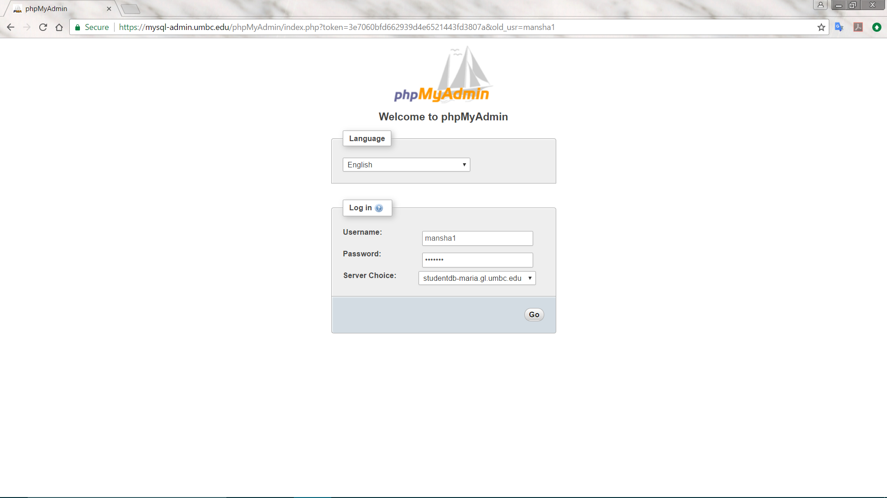

The database has two tables used by the game. The 'high_score' table contains the players who have successfully traveled the Oregon Trail and finished the game. The 'tombstones' table contains those players who failed to reach the end of the trail, and "died" along the way. The two tables do not have any relational operations between them.

Each entry of the 'tombstones' table has an ID number (used as the primary key), a timestamp, a virtual "date of death" to mark the date within the game (sometime in the year 1848), the name of the player, the mile marker where the player died, and a custom epitaph provided by the player.

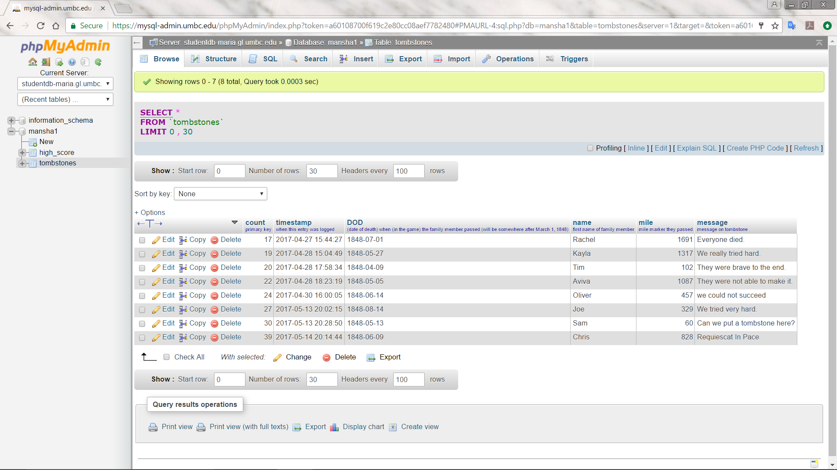

Each entry of the high_score table has an ID number (used as the primary key), the name of the player, the number of points scored, and a "rating" based on the points.

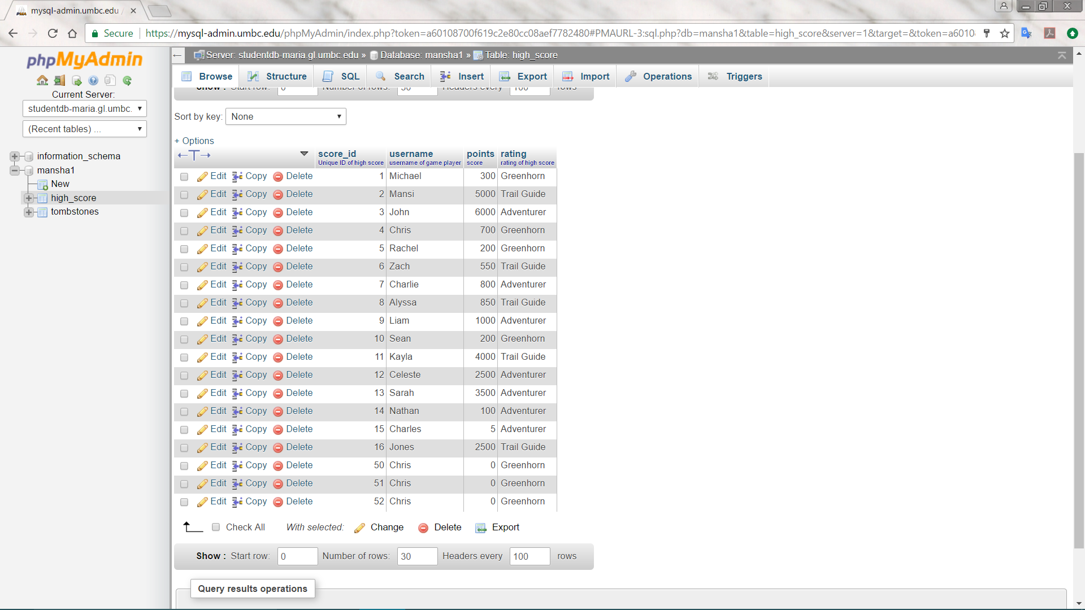

To see a dump of the database, look at the files 'high_score.sql' and 'tombstones.sql'

**Languages Used:**

We built our implementation of the game completely from scratch. JavaScript and jQuery were used to implement the majority of the functionality for the game. PHP, MySQL, and AJAX are used to connect to the database to retrieve data for the high scores and the tombstones.

The JavaScript library Bootbox.js was used to make the dialog boxes look more attractive. Bootbox requires Bootstrap.

**Slick Sheet (how to play):**

To play the game, open the file proj2.html or go to:

<https://swe.umbc.edu/~kelbaum1/Oregon/proj2.html>

The Title screen will display. Click "Start the Journey" button to continue.

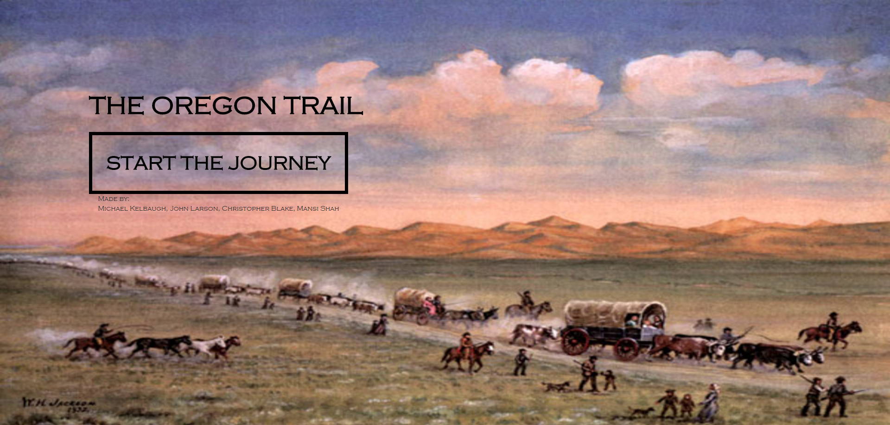

Next, the Setup screen will display. Select the type of player that you want to be (banker, carpenter, or farmer). This will determine how much money you have at your disposal. However, if you complete the journey after having begun with less money, you will earn more points.

You can also select the name of your wagon leader. This will be the name used either when you make the trip and record your score, or if you fail and record the message for your tombstone. The names of your 4 partners are given by default, but you can change these too. Finally, select the starting month for your journey and click 'Continue'.

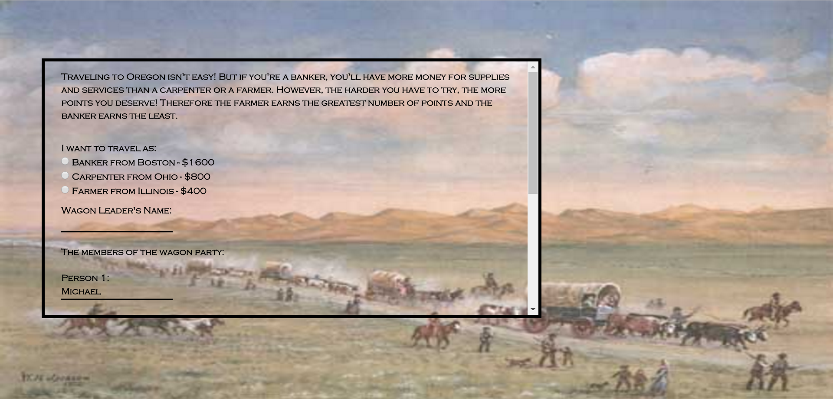

Next, the General Store screen will display.

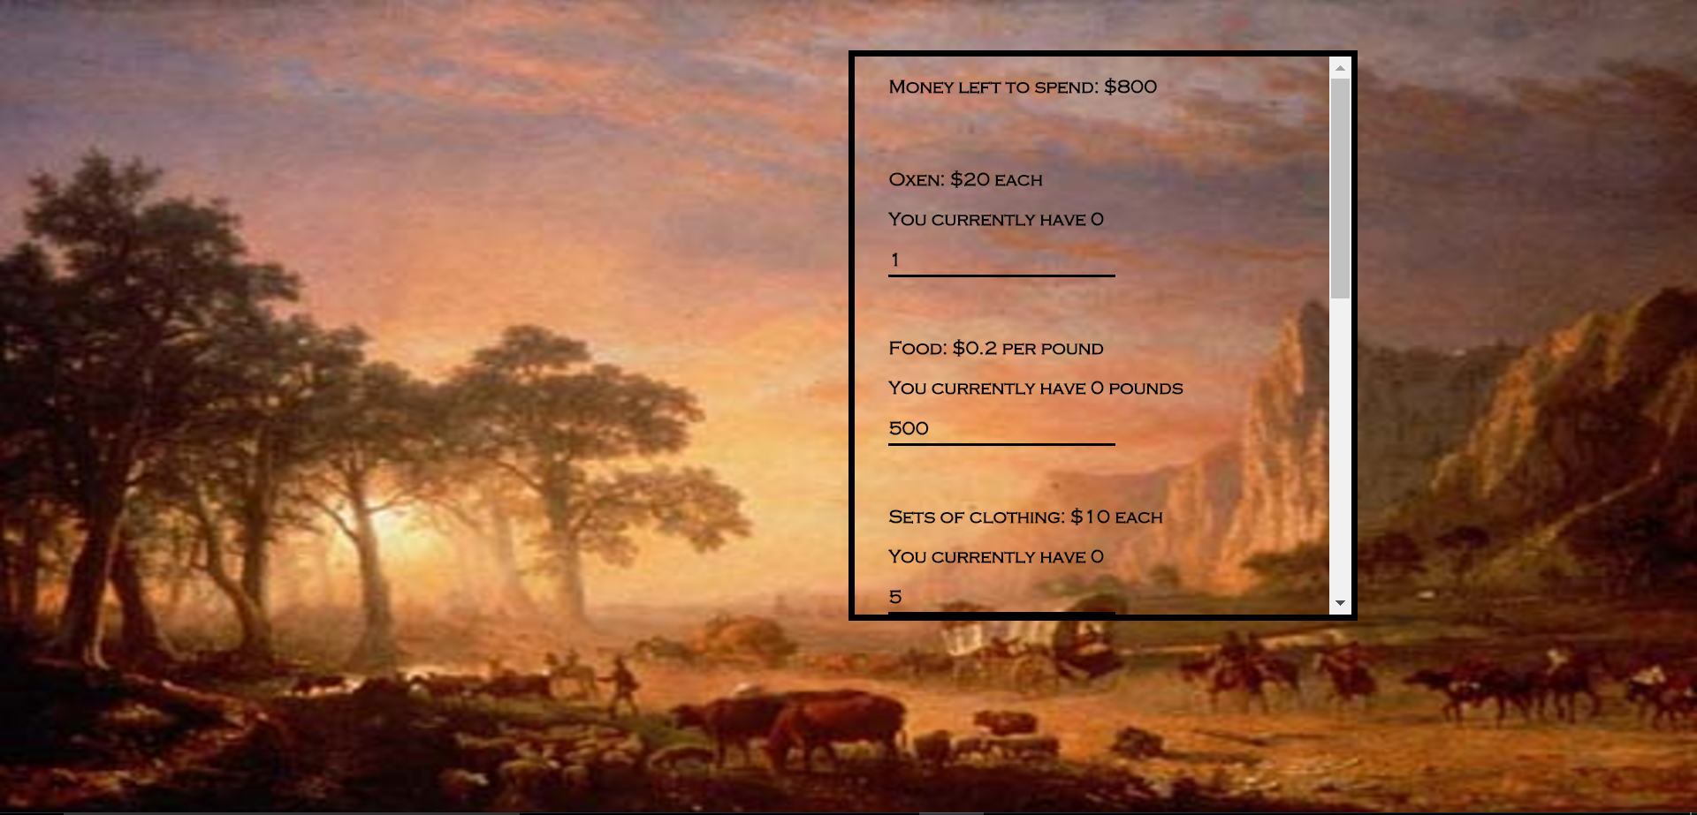

You will see your budget, which is the total amount of money you have left to spend. You can choose to spend all of it (not recommended) or only some of it.

* Oxen -- the first time you visit the store, you will have to buy at least 1 ox to pull the wagon. The more oxen you have, the faster you will travel. Each oxen will cause the wagon to travel 1 mile per day at a steady pace, 2 miles per day at a strenuous pace, and 3 miles per day at a grueling pace.
* Food -- you need food in order to stay healthy.
* Clothing -- you need clothing in order to stay healthy.
* Bait -- you can use each piece of bait to 'go fishing' and catch a random number of fish. This will increase your food supply by 10 pounds per fish.
* Wheels, axles, and tongues -- you will need these spare parts to repair your wagon, in case it breaks down.

Once you have finished purchasing your supplies, the main game page will display.

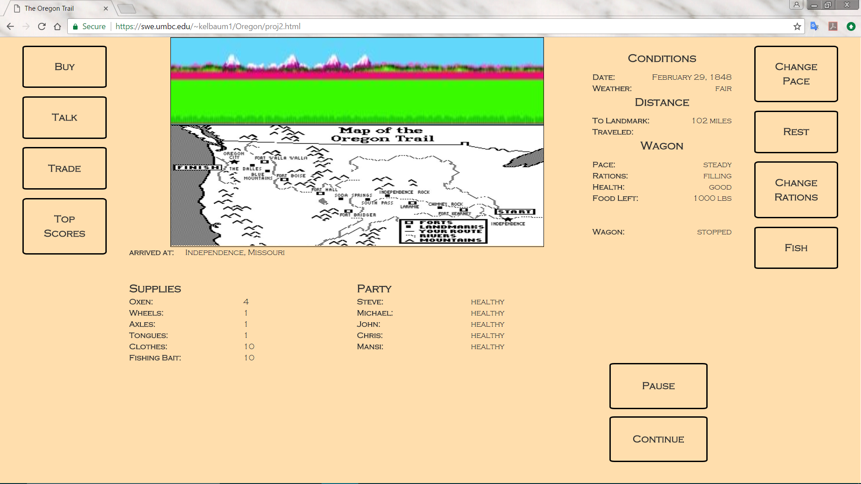

If you forgot to purchase something at the store, you can click the 'Buy' button to go back. Otherwise, click 'Continue' at the bottom of the page to begin traveling.

To begin or resume travel throughout the game, simply press the 'Continue' button. To stop traveling, press the 'Pause' button.

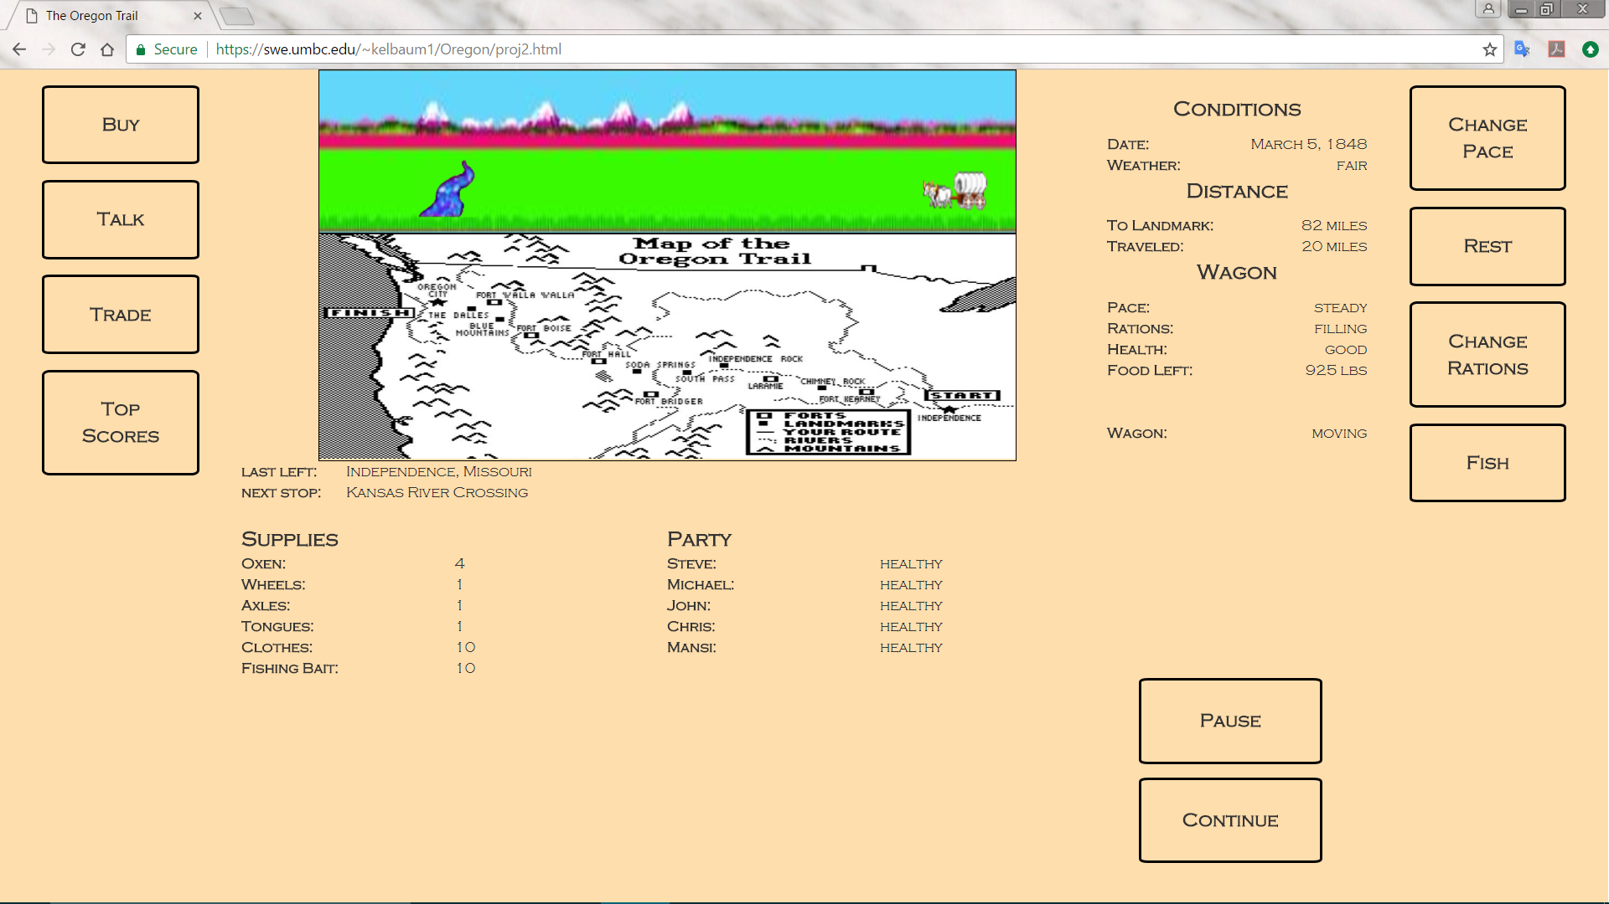

The top graphic shows the wagon moving toward the next landmark, which in this case is the Kansas River Crossing, as shown by the 'Next Stop' status below the map. The wagon has left the city of Independence, as shown by the 'Last Left' status. The wagon will continue moving until it reaches the next landmark, or until it comes across a tombstone, which it will then display to the screen. The date in the 'Conditions' pane will increment, and the weather will change at random. The values in the 'Distance' pane will also update automatically as the wagon moves.

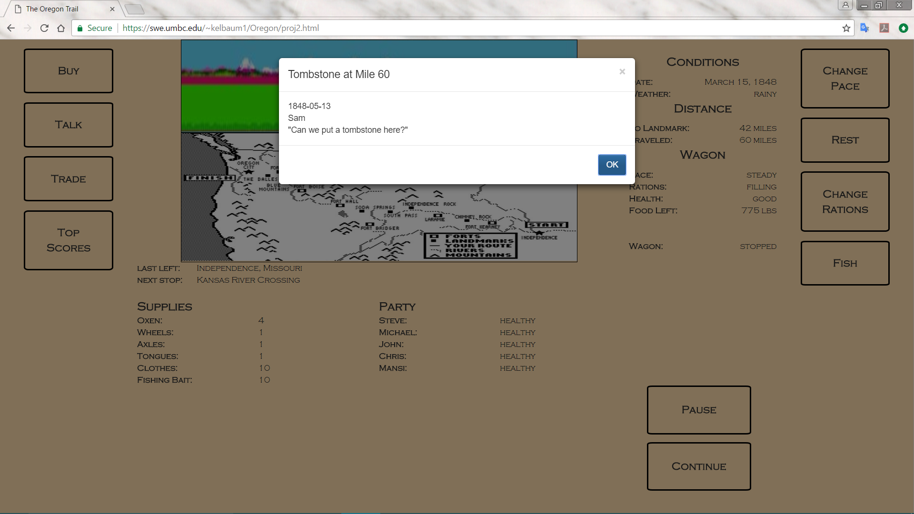

*The wagon stops traveling once it reaches a tombstone. "Sam" didn't make it very far, and died at mile 60.*

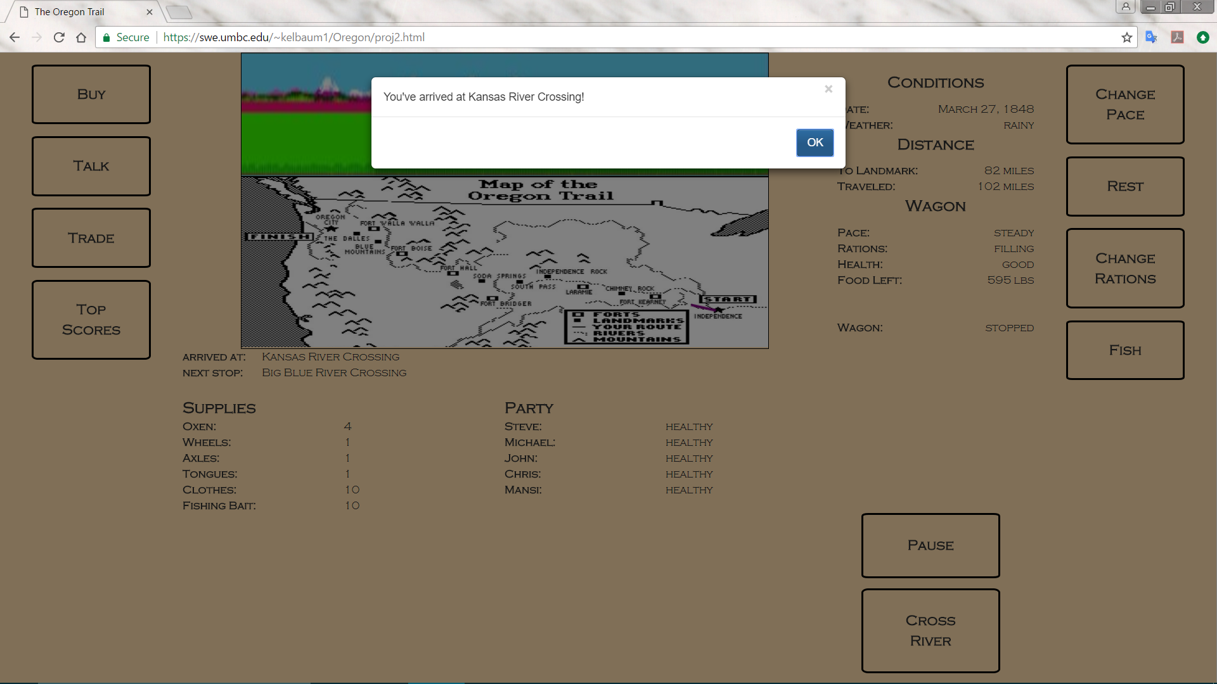

*The wagon stops traveling once it reaches the next landmark, which in this case is the Kansas River Crossing.*

Upon reaching a river, the player will be prompted to begin a river crossing event. In this event, the player will be given randomly generated values for the river’s width and depth.

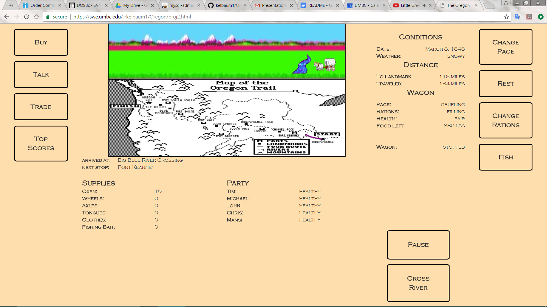

*Getting ready to cross the Big Blue River.*

The player will be given the option to ford the river, caulk the wagon and float across the river, take a ferry for $10 or wait to see if conditions improve. If a river is too deep a player would be ill advised to try and ford the river. If a wagon is too heavy, it would be a bad idea to attempt to float across. A ferry can improve a wagon’s chances of floating across, but only up to a point. Waiting can also be costly, as spending too many days waiting for conditions to improve will find your wagon struggling through the winter months by the time it gets out west! Failure to cross the river will mean that the wagon will sink, and the player will lose some supplies.

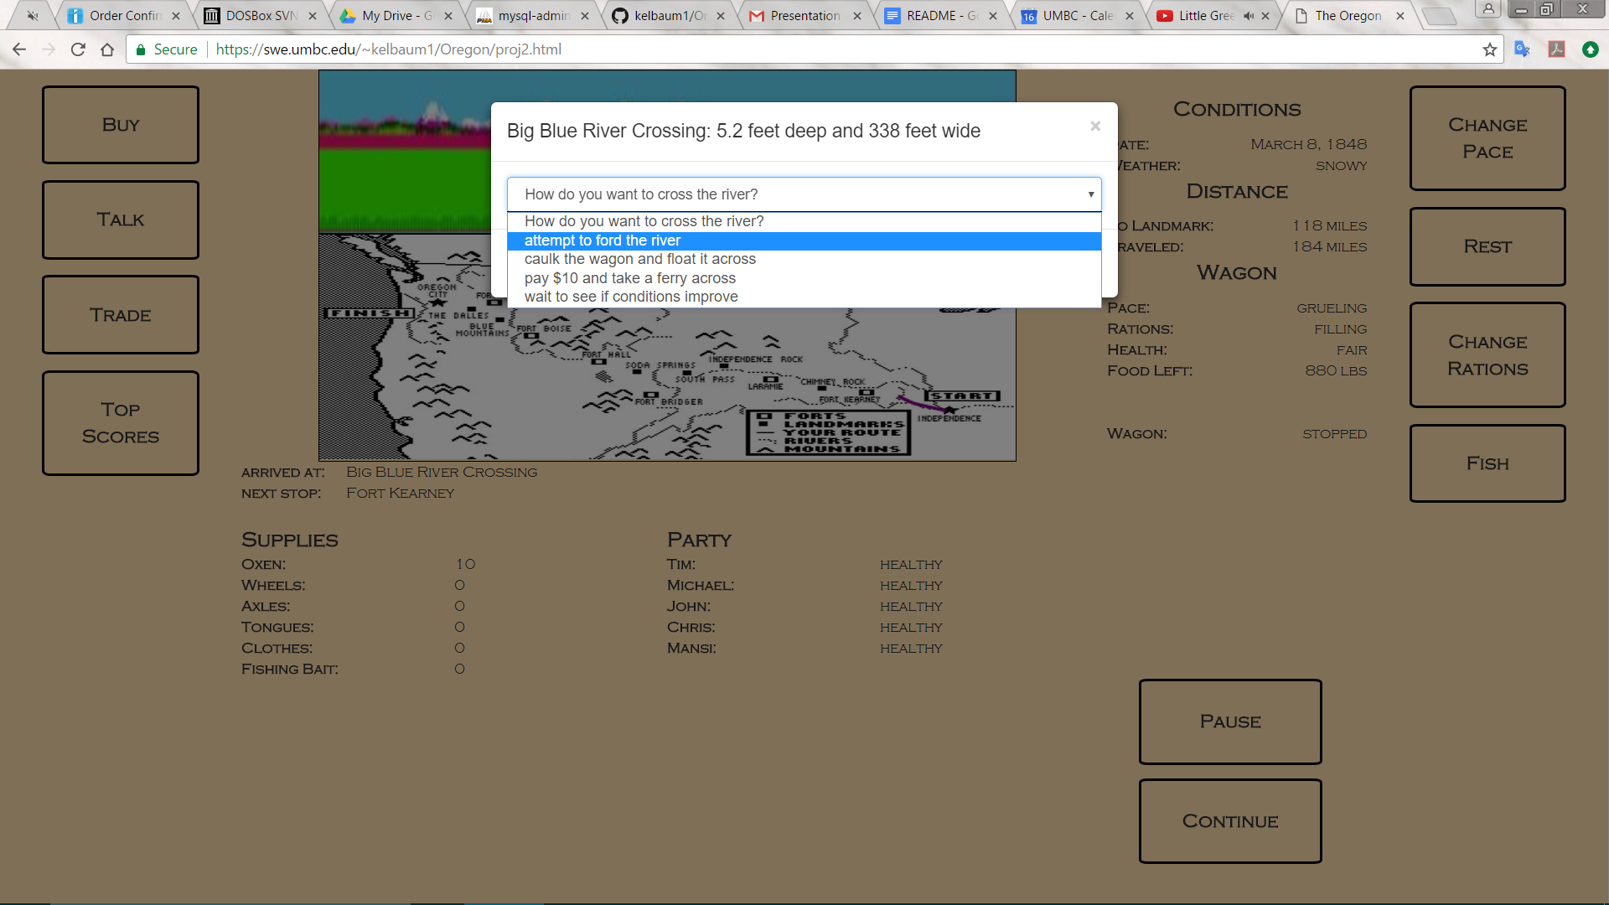

*After clicking the 'Cross River' button*

Depending on the food supply and the pace of the wagon, the health of each member of the wagon party will also update under the 'Party' pane. The wagon will also stop traveling and display a message if someone in the party gets sick, or dies.

The 'Supplies' pane will display the quantity of each supply in the wagon. These values will update if you purchase more supplies at the store, if you lose some items while crossing a river, or if you trade for supplies.

Once you arrive at a fort, you will be able to purchase more supplies at the general store by clicking the 'Buy' button. This will take you to the same Store page that you saw when beginning the game. Be aware, however, that store prices will increase as the game progresses!

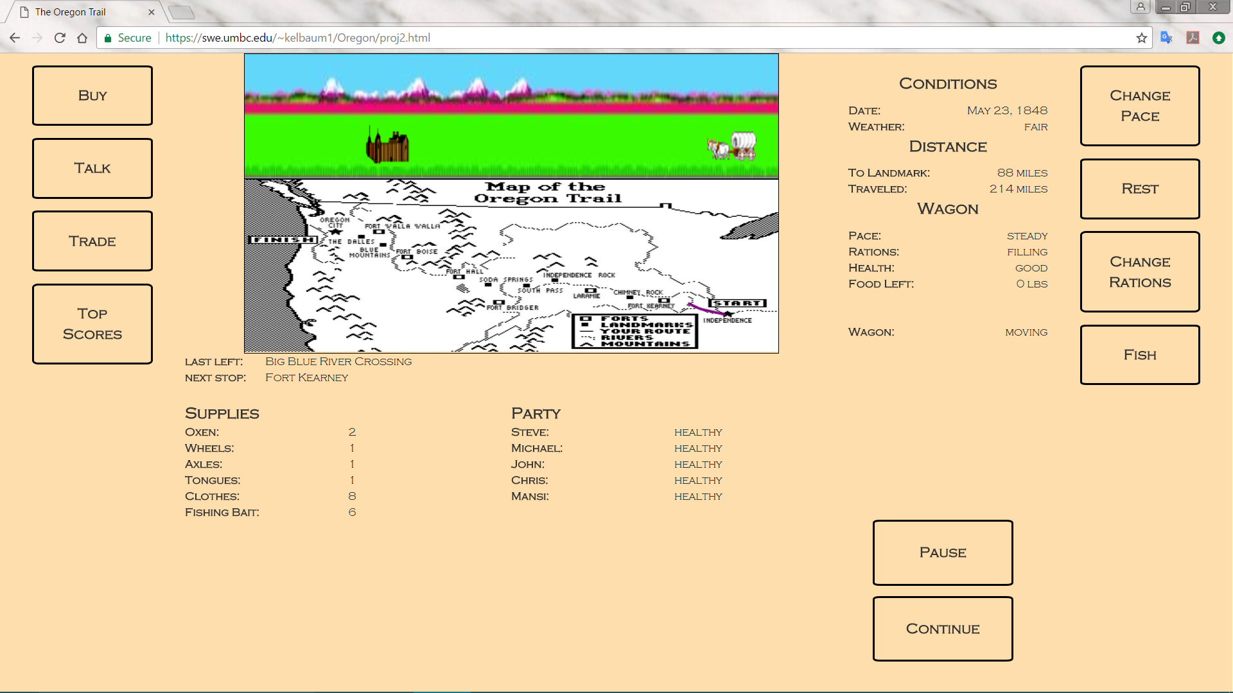

*The wagon moves toward Fort Kearney.*

If you don't want to spend money, you can also trade for supplies by pressing the 'Trade' button. This will generate a random trade deal that you can choose to either accept or reject.

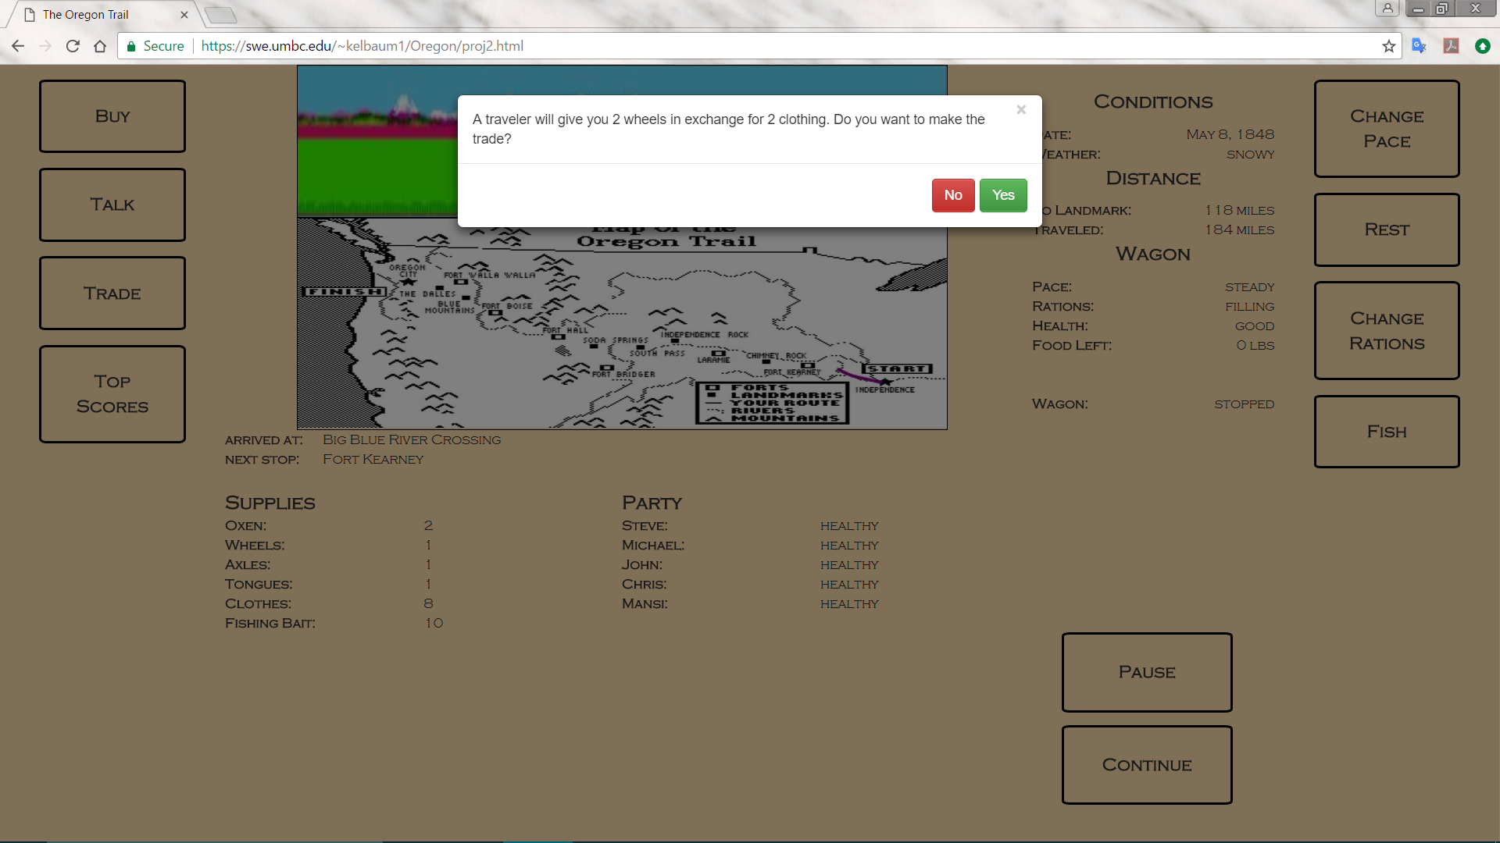

If you are at a fort, you can also press the 'Talk' button to get some tips from other travelers.

If you click the 'Top Scores' button, you can see the top 10 scores for the game:

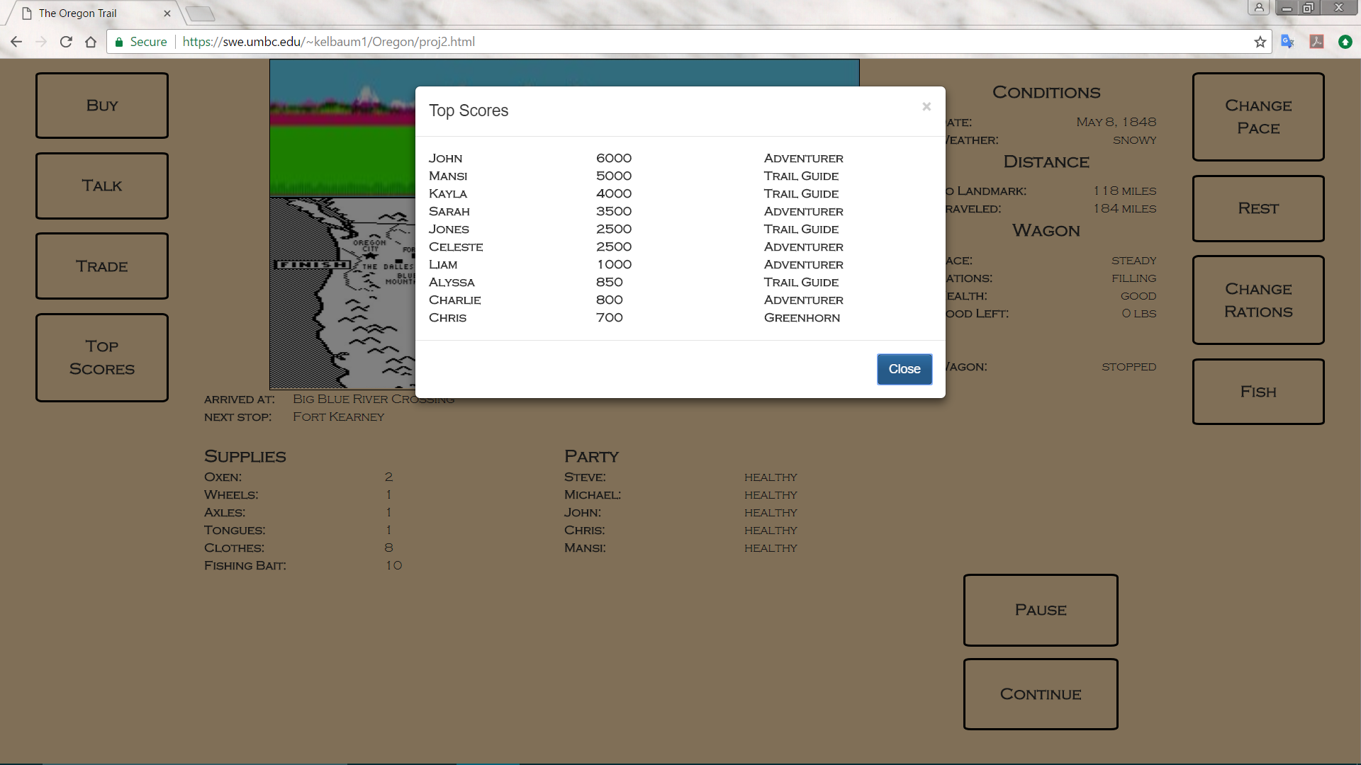

In order to move faster, you might want to click the 'Change Pace' button and select a faster pace. However, if your pace is 'strenuous' or 'grueling', your health will suffer.

In order to conserve your supplies, you might want to click the 'Change Rations' button and select a smaller ration size. However, if your rations are 'meager' or 'bare bones', your health will suffer. A 'filling' ration is 3 pounds per day per person, a meager ration is 2 pounds, and a bare bones ration is only 1 pound.

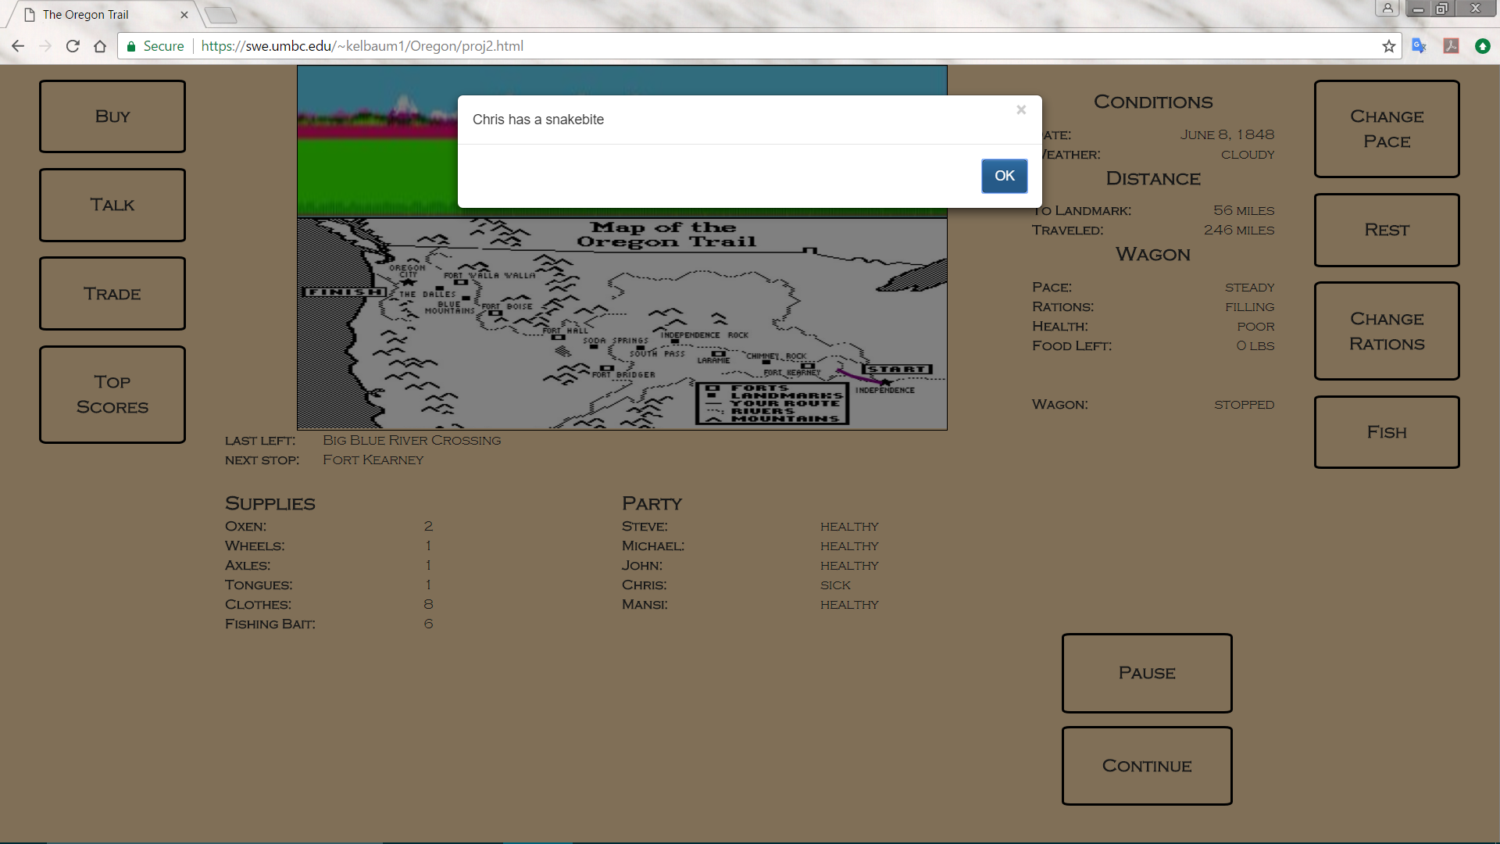

*If your health is bad (In this case, "poor") accidents like a snakebite are more likely.*

If your health gets precariously low, you will want to click the 'Rest' button in order to rest up and restore your health. However, you will still need to eat, so don't rest if you've run out of food!

If you want to increase your food supply, click the 'Fish' button to catch a random number of fish for a total of 0 to 200 pounds.

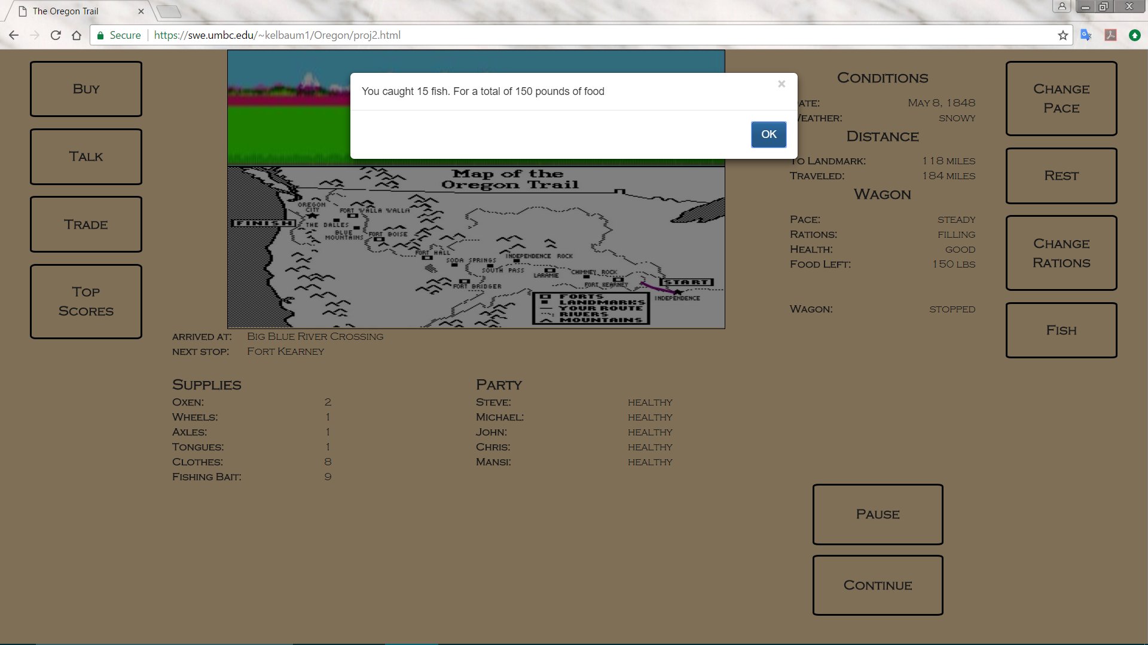

As you progress through the game, the map will display your route by drawing a trail (the purple line):

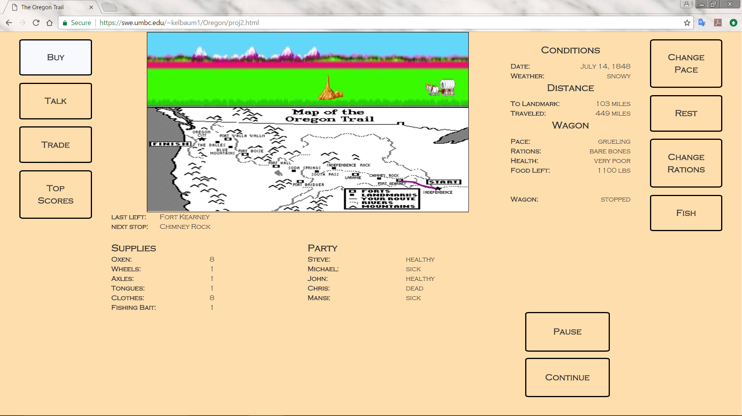

*The wagon is heading toward Chimney Rock.*

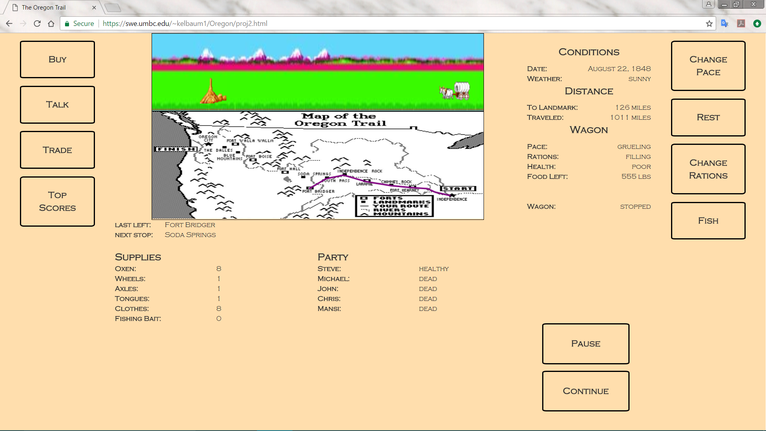

*Later on in the game, the wagon has reached Fort Bridger.*

At the end of the trail upon reaching the “Blue Mountains,” if the player decides to head to the “Dalles River,” then upon arrival they will be prompted to play a river crossing minigame. The object of this game is to navigate their floating wagon down a fast-moving river, whilst avoiding rocks which will be constantly spawning. The player cannot truly “lose” this game, as they may hit as many rocks as they would like without dying. However, every rock which is hit will cause the wagon to lose inventory, lowering the player’s final score. The game is played using the arrow keys and will automatically end after a certain time has elapsed.

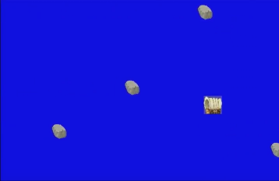

Upon finishing the river crossing mini-game, the player will have opportunity to record their score, which will be stored in the database. If the score is high enough to be counted as one of the top-ten highest scores, it will also be displayed on the Top Scores page.

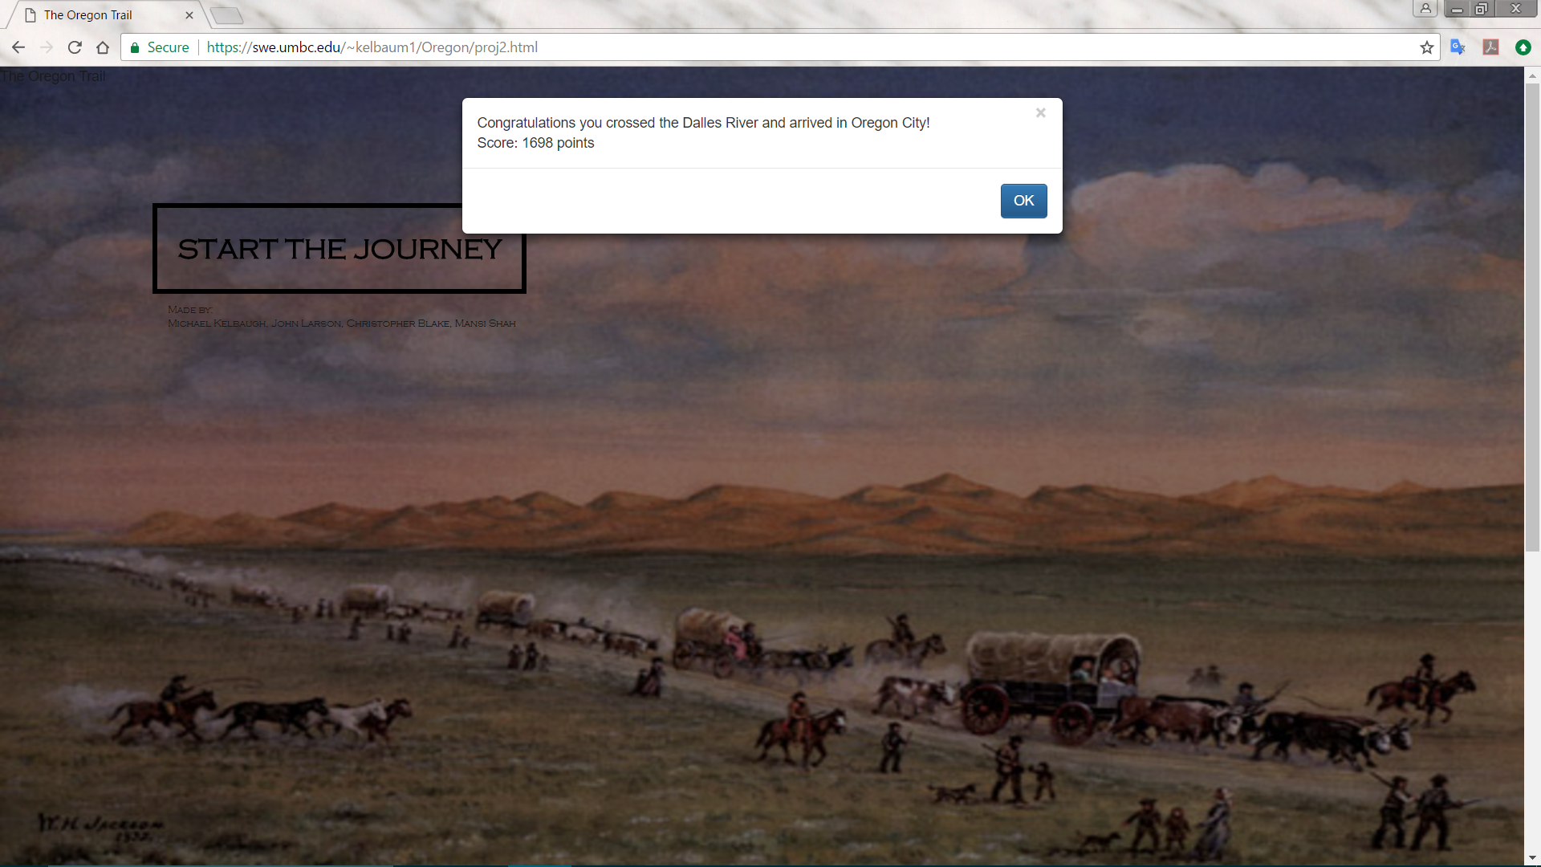

If all 5 members of the wagon party die along the way, the player will be prompted to record an epitaph for their tombstone:

This message will be recorded in the database. The next time a player reaches that mile marker in the game, the message will be displayed.

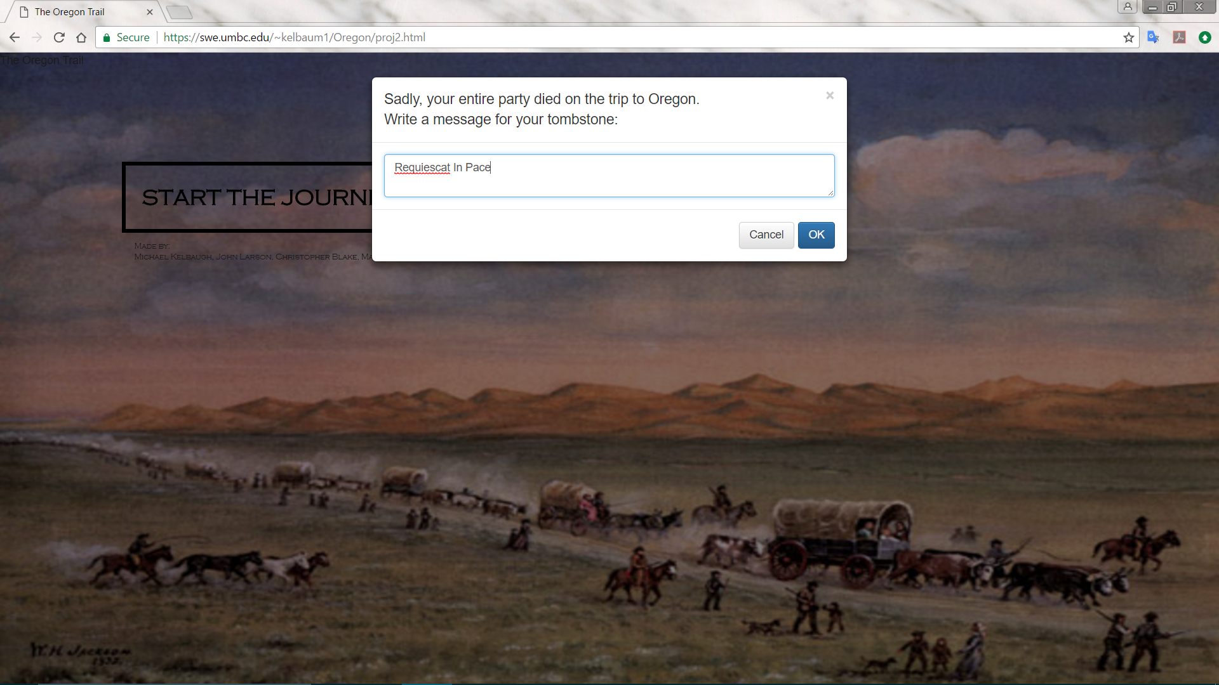

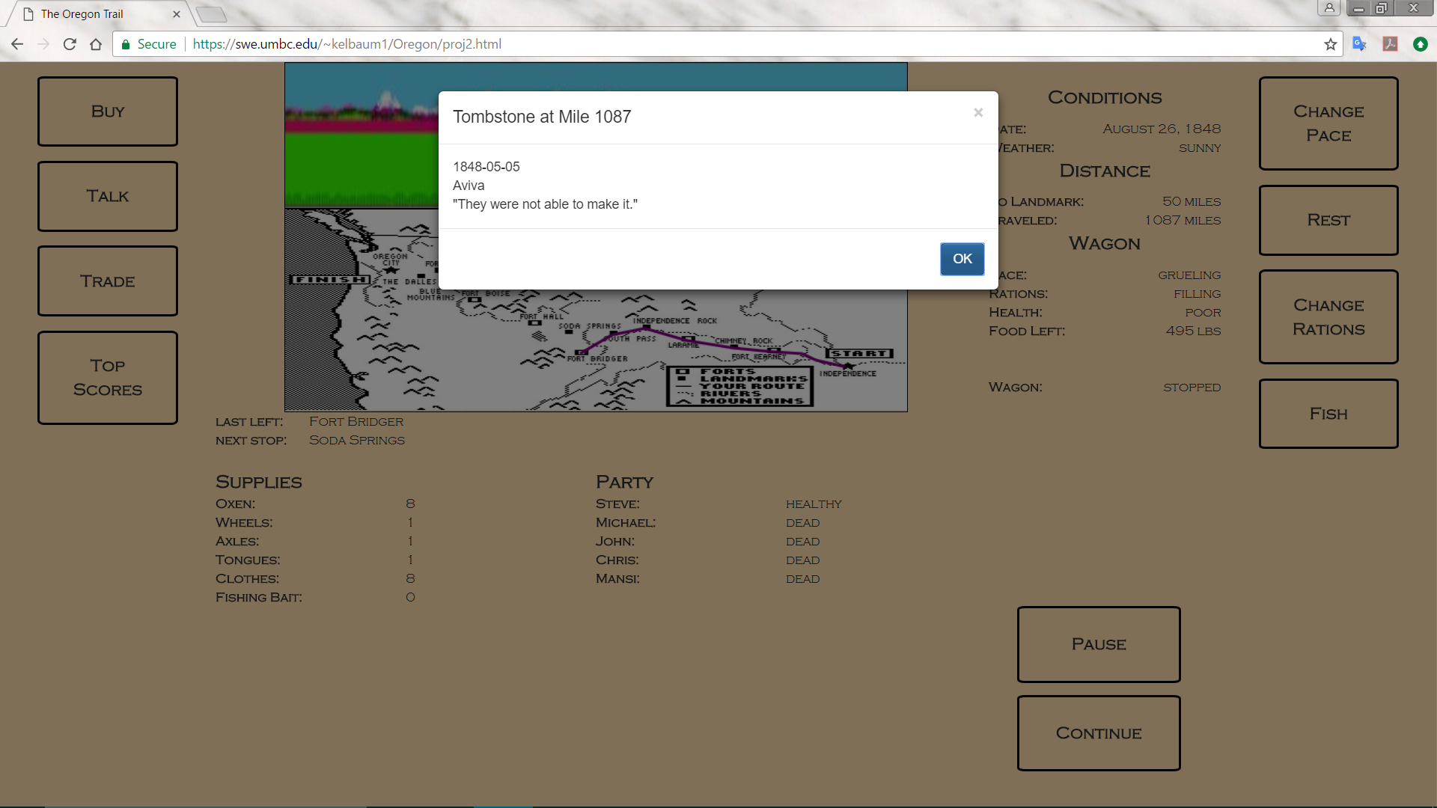

*Once the wagon passes by mile 1087, it will stop to look at Aviva's tombstone.*

**THE END**